Kaizen Tools for Root Cause | Pareto | When there are multiple possible causes for process or when there are multiple known contributors or modes to a problem.

A pareto does not require a team or a brainstorming session.
Examples:
- a bottling process has several failure modes, missing caps, crooked caps, caps not being tight enough (leaks), empty bottles, fallen bottles, broken bottles, bottles not filled to the right level.
- Lawnmowers are being returned in the warranty period because of blades wearing out, motor seizes, motor too loud, parts fall off, throttle sticks, oil leaks, hard to start, won’t start, pull string breaks.
Goal: Find the failure modes that need to be addressed first to reduce the failure frequency by 80%.
Use:
- Count all the instances of the various sources, sort by descending value
- Determine percent of each value against total incidents
- Plot chart to view highest contributors
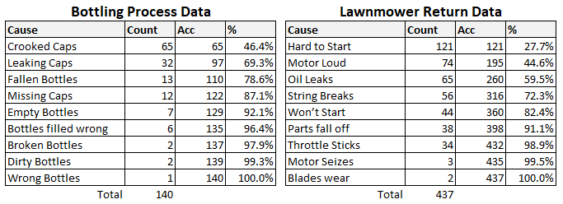
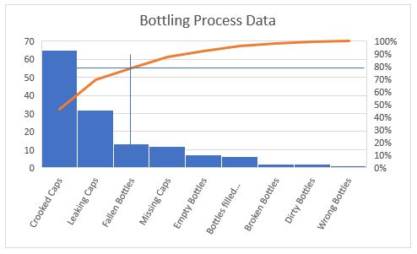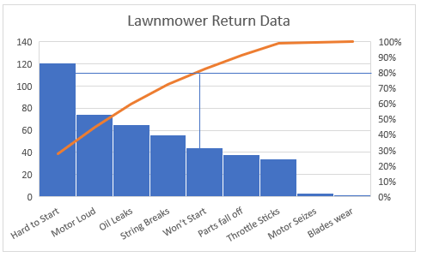

Kaizen Tools for Root Cause | Five Whys | When there is a single failure mode with few or one likely cause

Five Whys requires a team and a brainstorming session.
Example: A custom kit was delivered with two parts missing.
Goal: Find the cause or causes that contributed to the failure.
Use:
- Determine the problem statement (choose carefully)
- Ask WHY this problem occurred and determine a best fit answer. Keep in mind the answer is rarely or never a person (operator error).
  - This first answer may occasionally trigger an improvement opportunity, but often not.
- Ask WHY this condition was allowed to exist or WHY this answer occurred. Find a best fit answer – sometimes there is more than one reason why that might become a branch to follow. For the purposes of focus, choose the best fit to pursue.
  - The answer to the second why will often trigger an improvement opportunity.
- Ask WHY this condition was allowed to exist or WHY this answer occurred. Often at this, the third WHY, the temptation begins to either become circuitous or focused on an individual. Neither of these are acceptable answers – the team should brainstorm what controlling element was missing.
  - The answer to the third why invariable leads to at least one improvement opportunity.
- Ask WHY this condition occurred. At this point the depth of the brainstorming has often lead to controls surprisingly outside the environment of the problem and the temptation to stop appears. Do not stop – continue brainstorming.
  - The answer to the fourth why may lead to multiple improvement opportunities.
- Ask WHY this condition occurred. This far into a problem has usually uncovered areas that have not been considered at all.
  - The answer to the fifth why will almost always lead to one final improvement opportunity.
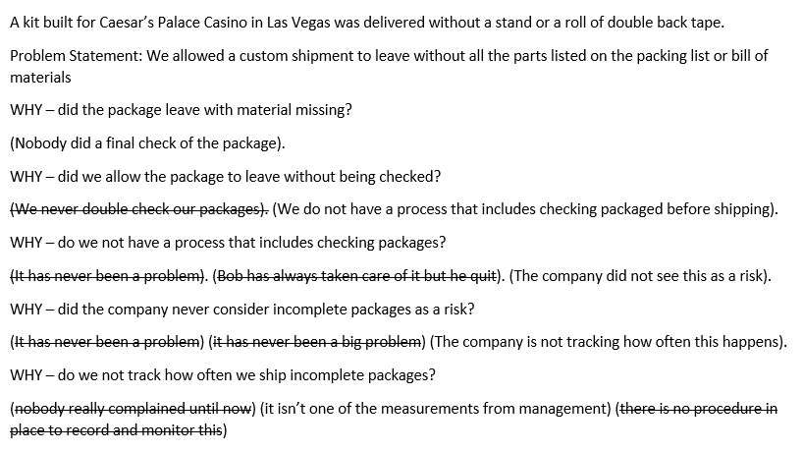
Kaizen Tools for Root Cause | Fishbone Diagram | When there is a single failure mode with no specific known cause but multiple potential sources

A Fishbone Diagram requires a team and a brainstorming session.
Example: A batch of soda was shipped and found to be not carbonated.
Goal: Find the most likely (or top three) causes
Use:
- Draw the diagram with the failure mode as the head
- As a team, brainstorm through each of the six classifications of cause – Material, Method, Measurement, Man(power), Mother Nature, Machine.
- Each team member identifies the top three candidates they suspect rating the most likely as a 3, the least likely as a 1. After each team member has voted, all remaining potential causes are set aside.
- For each remaining cause, as a team the cause is rated by potential impact. Largest impact is rated a 3, least impact a 1.
- Multiply all weights for each potential cause.
- The top three weighted potential causes are the resulting candidates to pursue
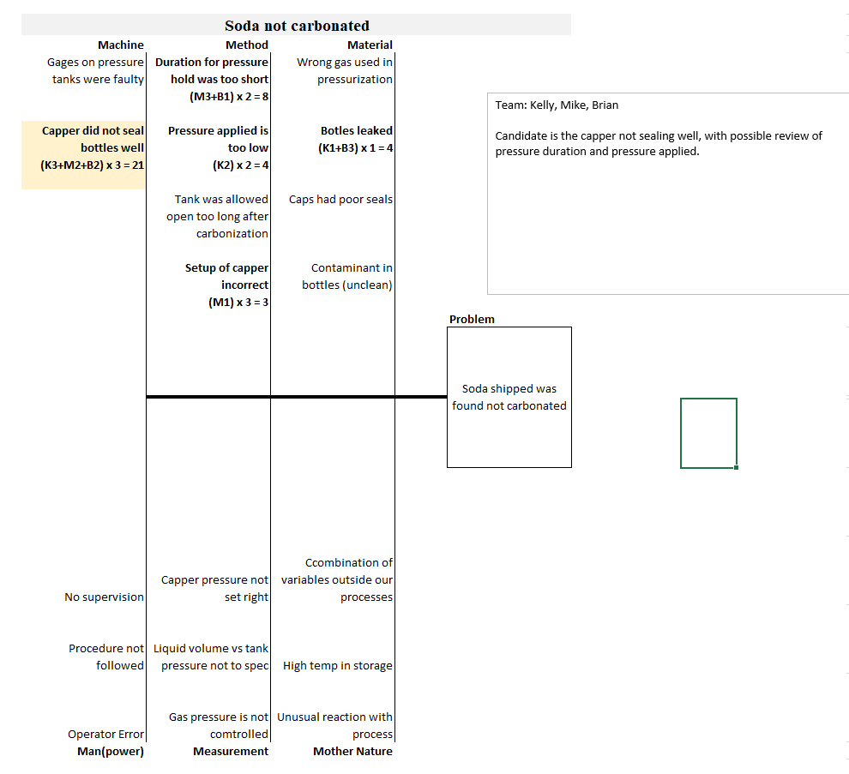
Kaizen Tools for Root Cause | Waste (Muda) Hunt | Identifying waste in a process to identify where improvements can be made

Muda hunt requires a team and a brainstorming session
Example: A conveyor assembly to package 5000 units of tablets takes a week with a crew of 16 people. Every batch packed to date has had complaints of missing tablets or missing parts (case, card, etc).
Use:
- Know the seven forms of waste to find (TIMWOOD):
  - Transportation – the unnecessary movement of material.
  - Inventory – parts in bins or on the shelf that are not actually needed for this assembly, often ordered to either reduce lead time risk or to decrease part cost.
  - Movement – unnecessary operator motion like walking back and forth from inventory
  - Waiting – the time between actual work, usually easily seen in a Time Study.
  - Over Processing – something done more than once, most often inspection or test.
  - Over Production – making more assemblies than necessary, usually because the setup is complete – why not?
  - Defects – not defects typically as in bad parts (although that’s a problem), but defects in the process, usually where a process is not being followed
- Walk the process (follow one part through) and/or map the process.
  - Take lots of notes
  - Take lots of pictures
  - Time everything
- Map the process. You are capturing a moment like a photograph, if something unusual happens record it as if that’s what always happens. Do not accept “this never happens” as a reason to not record the issue.
- Identify the waste using the TIMWOOD mnemonic.
- Where the waste is unavoidable, note this.

