Kaizen Tools for Current Condition | Spaghetti Diagram | To establish a current state view of the movement of operators in a process (Movement Muda)

Spaghetti Diagram uses a team of at least two (three is better).
Example: a receiving inspection department is looking for ways to reduce the time for product to pass through inspection.
Use:
- You will need a stopwatch and a walking measuring wheel. You will also need a floor plan of the process area and a pencil.
- For each part of a process follow the individual as they work the process, literally walking every step they take using the measuring wheel to record distance and the stopwatch to record time.
- For each path walked sketch the path onto the map. It is acceptable for paths to overlap (they usually do).
- As the paths are sketched record a table of each path with length and time, noting where the path started and stopped. (NOTE – this method can be used to track transportation of material if that is the focus of the study)
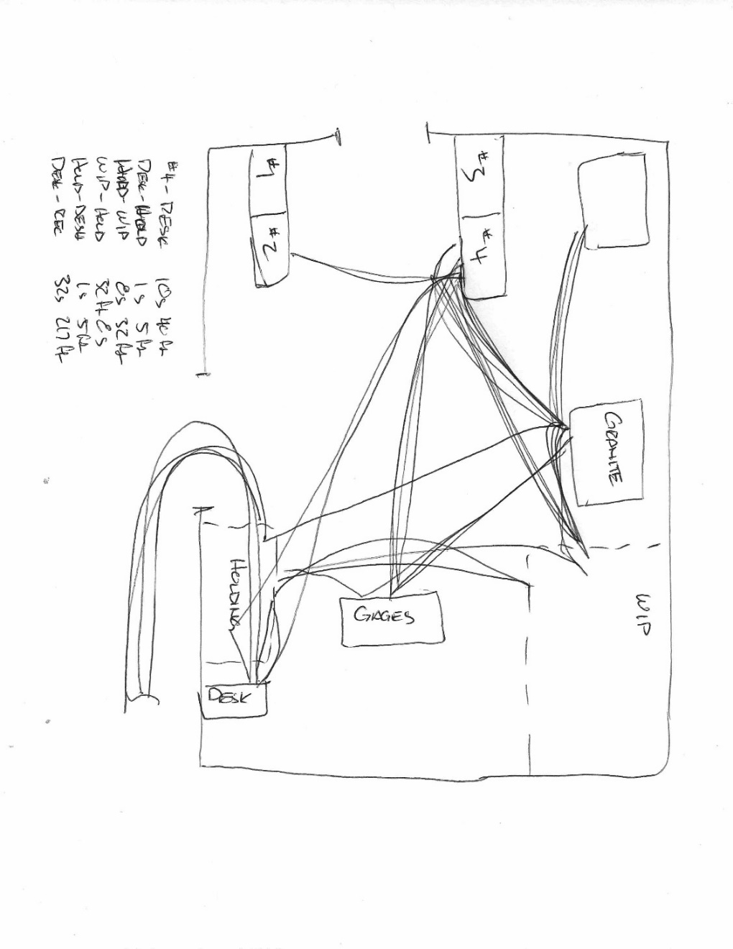
Kaizen Tools for Current Condition | Process Map | When a detailed understanding of a process is needed – most often for a business process – and the process includes planned if/or functions and intentional loops.

Process Map can be an individual effort but usually a team review. One of the most common tools in process understanding or development, often used in software development and controls management.
Use:
- Follow the process and map the controls for Input, Output, Decision, etc. Complex processes can span pages and should use the Sub Process or Process Connector symbols to link one sheet to another.
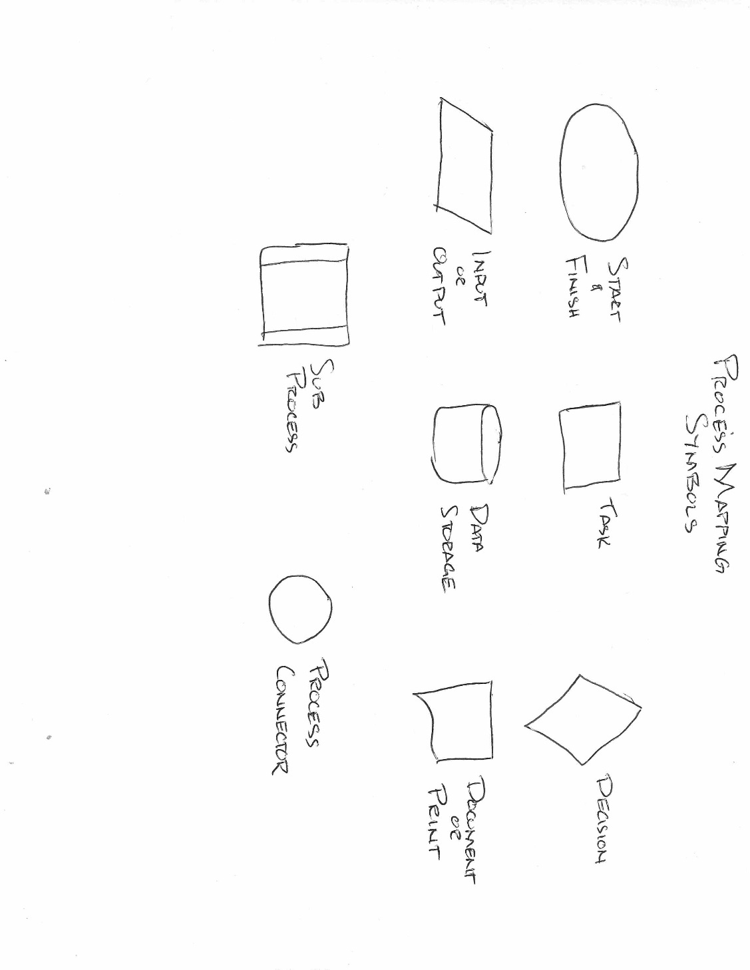

Kaizen Tools for Current Condition | Value Stream Map | When a detailed understanding of a process is needed, including means of communication and management of outside resources

Value Stream Map requires a team, a collection of data, a brainstorming session and significant time (>2 hrs)
Example: DC servo motors are built on a production line that changes very little from one model to the next. The production manager is interested to know if there is room for improvement in the line as it takes 18 weeks to run a batch of 2400 armatures.
Use:
- The key to developing this map is to understand you are building a snapshot of what is actually going on, not a theoretical model. All observations, no matter how unusual or surprising, are to be included.
- Follow one example product through the process to develop the essential map (Process Map)
- Identify external sources to the process, i.e., vendors, warehouses, shipping. Show how they are connected to the process.
- Identify the control sources such as purchase orders, work orders, shipping orders. Show where they come from (and are returned to) such as Production Control, Planning, Quality Control.
- Identify where inventory in the process is kept and note how much inventory is in each location. Use this map to identify opportunities for improvement.
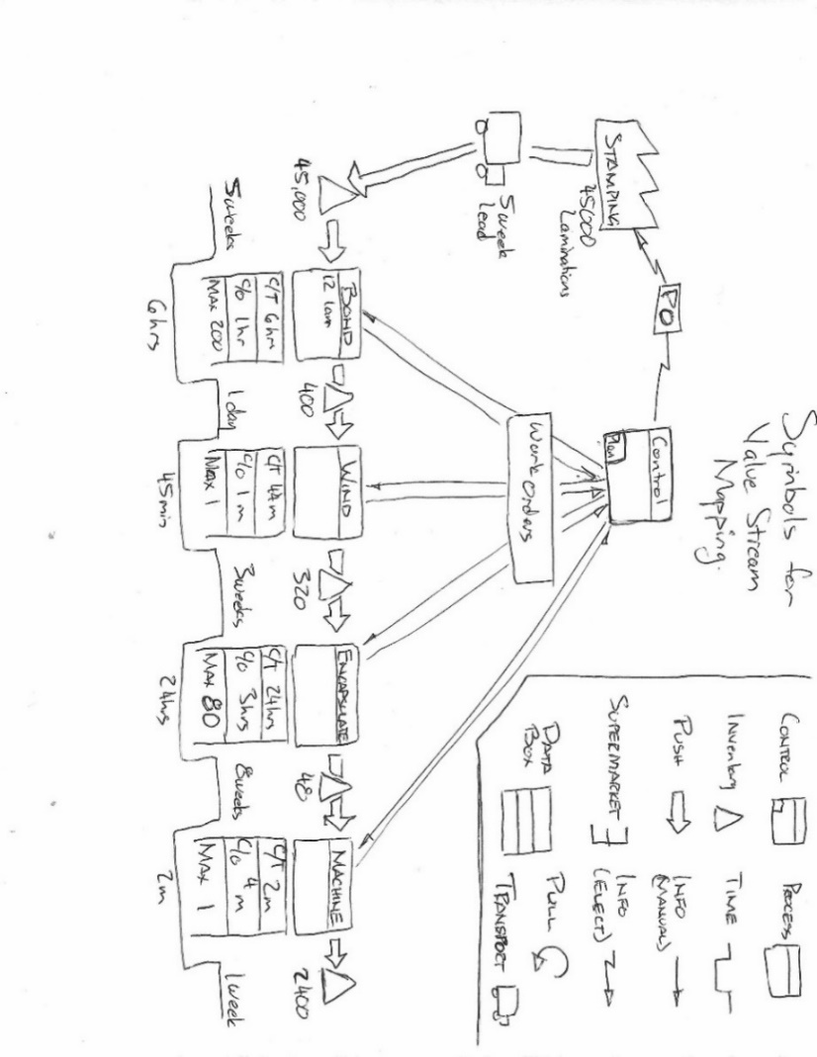
Kaizen Tools for Current Condition | Time Study | Use to collect fine detail data regarding a process flow (often part of developing a VSM)

Time Study requires a team, a collection of data, and a brainstorming session.
Examples:
- A receiving inspection department takes 2 weeks to 6 weeks to receive and release machined parts from outside vendors. Management wants to know if it can be done in one day.
- A screw machine setup takes a minimum of 6 hours, the run for production is often less time than the setup.
Use:
- Collect data using one of these methods (others can be created)
  - Stop watch and observation – follow a product through the process timing each interval
  - Video recording – use a video camera and analyze the recording to collect the data
- Map the data on a timeline (often best with a pencil and paper) using the following symbols
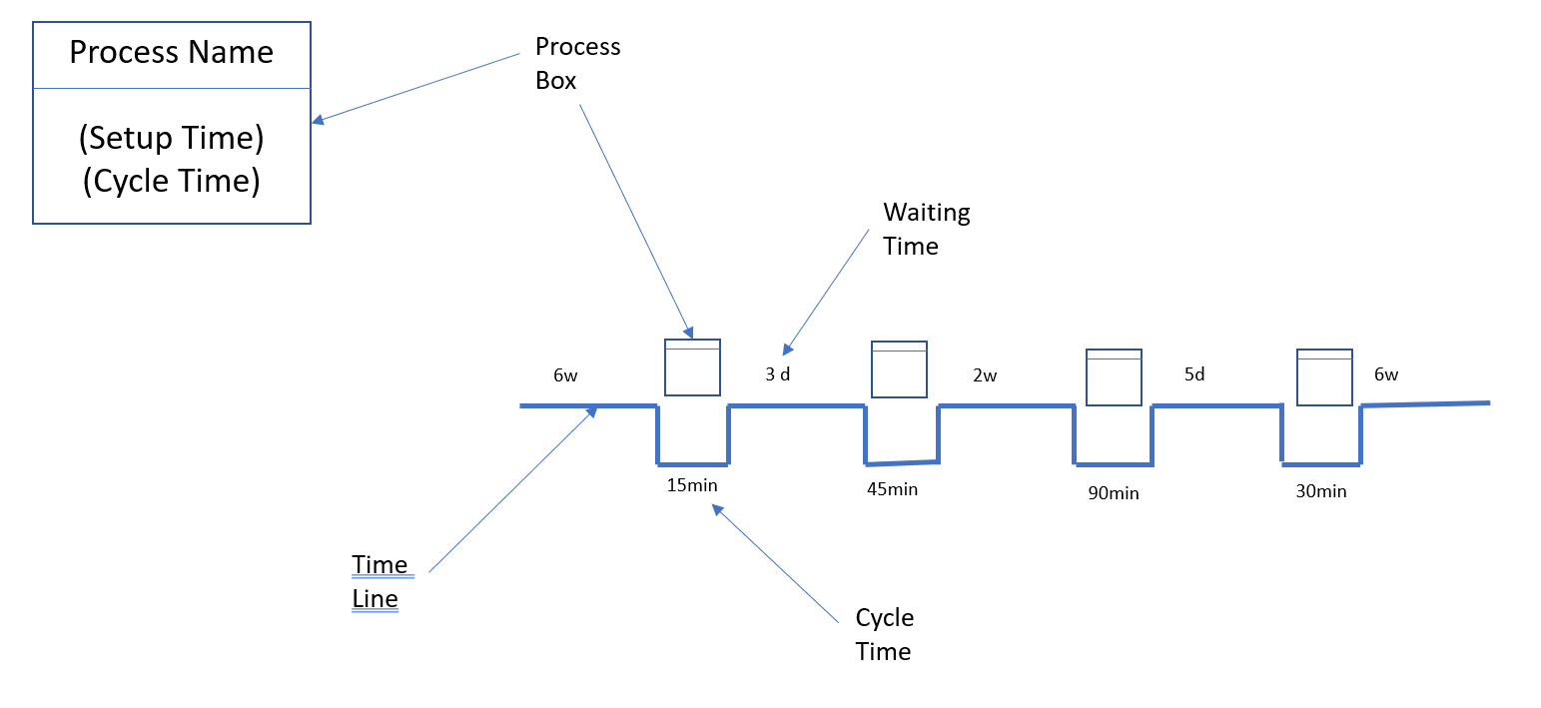
- Once the map is laid out study both the waiting time and the process box cycle time to see what advantages can be exploited (i.e., parallel processes, combining processes, replace wait with pull, etc)
Note: The time study is the first step for a Value Stream Map.

Kaizen Tools for Current Condition | Video Study | Use to record fine detail of a process for review, often the first step for SMED

Video Study requires a team, often more than one video camera, and a crew willing to be filmed.
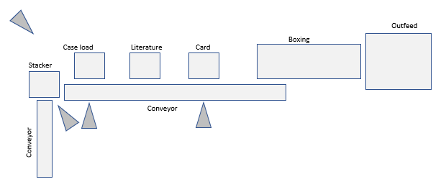
Example: locating the cause(s) for a conveyor-based packaging line intermittent failure
Use:
- Set cameras at all known failure points
- Run line until failure, observe video
- Introduce countermeasure
- Repeat until countermeasures are effective

Kaizen Tools for Current Condition | Gemba Walk | To get a true understanding of what is going on, whether for a one-time event, i.e., Kaizen or Management introduction, or a routine review. A Gemba Walk is the absolute best way to know the current condition.

Gemba Walk (for Kaizen) involves the entire team – plus – the production team

Steps:
- Ask permission from the department manager
- Ask permission from the team and explain what you are trying to learn and why
- Plan the visit
- Arrive on time
- Ask and listen
- Take notes and pictures as needed
- Leave as planned
- Thank the team for their help
Rules:
- Listen more than speak – pay attention
- Ask questions
- Show Respect
- Make no suggestions
- Be aware that the production team are the experts
- Continually returning to the Gemba is disrespectful – get your information the first time

